

**SNEAKER ONLINE SHOP**

**Final Release Document**

– Hanoi, April 2023 –

**Table of Contents**

I. Deliverable Package 3

II. Installation Guides 3

III. User Manual 3

1. Overview 3

2. Workflow 3

2.1. Admin 3

2.2. Guest 6

2.3. Customer 8

2.4. Employee 10

# I. Deliverable Package

| **No.** | **File** | **Notes** |
| --- | --- | --- |
| 1 | G5_DB_final.sql | Database, including both table structures and table data |
| 2 | G5 _SRS_final.docx | Final SRS (Requirement) Document |
| 3 | G5 _SDS_final.docx | Final SDS (Design) Document |
| 4 | G5_Final Product Backlog.xlsx | Final status for the application functions, which include:  - Function name, feature, roles, function description (changes compared to the original requirements are highlighted)  - In Charge, Planned iteration & Actual iteration  - Final status & note on the update you made  - The links to the SRS & SDS are tracked |
| 5 | G5_Issues Report.xlsx | Final issues tracking list of the whole project |

Other related deliverables:

* Tagged source codes: <https://github.com/TuanVu588/SWP391_BL5_G5.git>

# II. Installation Guides

* Environment install
* visual studio 2022 : [Here](https://visualstudio.microsoft.com/vs/)
* sql 2019 : [Here](https://www.microsoft.com/en-us/sql-server/sql-server-2019)
* dotnet 6.0 [Here](https://dotnet.microsoft.com/en-us/download/dotnet/6.0)
* Database
* Create database name : G5_DB_Final
* Import database XYZ_DB_final.sql
* Run Code
* Open code using visual studio 2022
* Run

# III. User Manual

## Overview

Sports shoes online store system is an online sales system on the Internet. This system aims for a friendly interface, easy to use and quick response

## Workflow

## 2.1. Admin

2.1.1 Luồng Admin quản lý Product

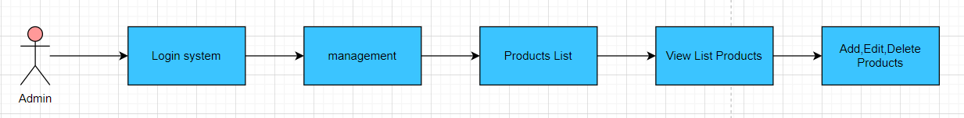

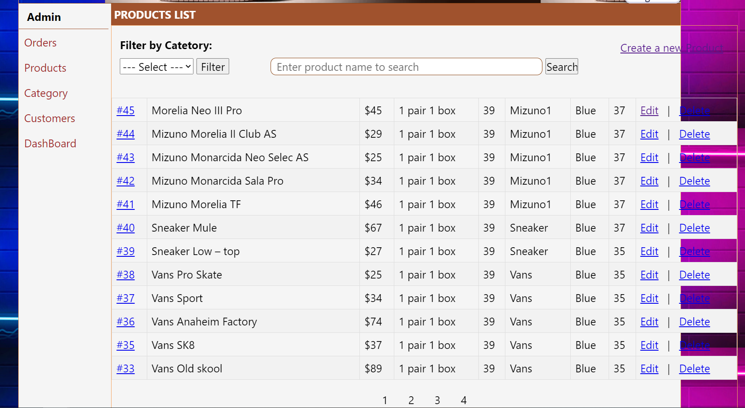

2.1.2 Luồng Admin quản lý Orders

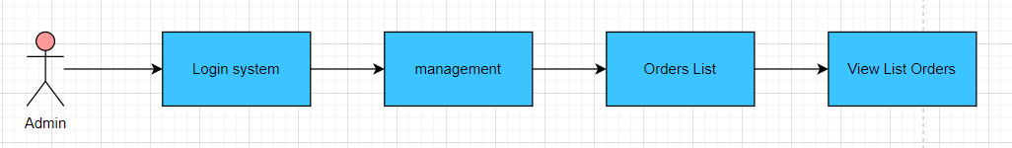

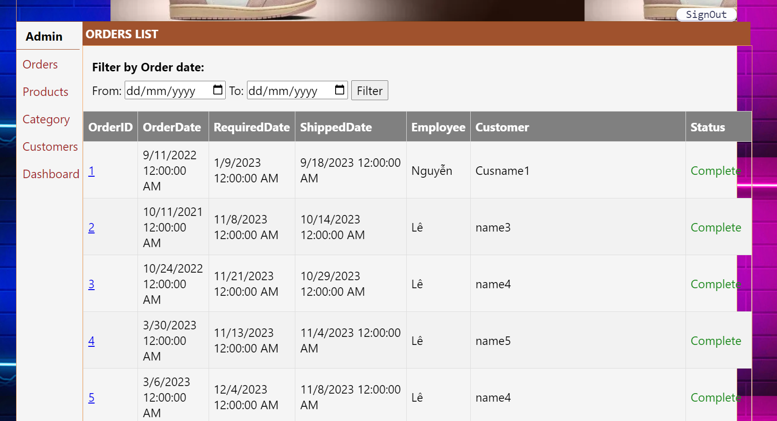

2.1.3 Luồng Admin quản lý Category

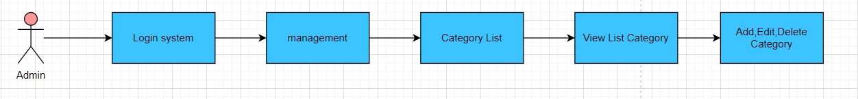

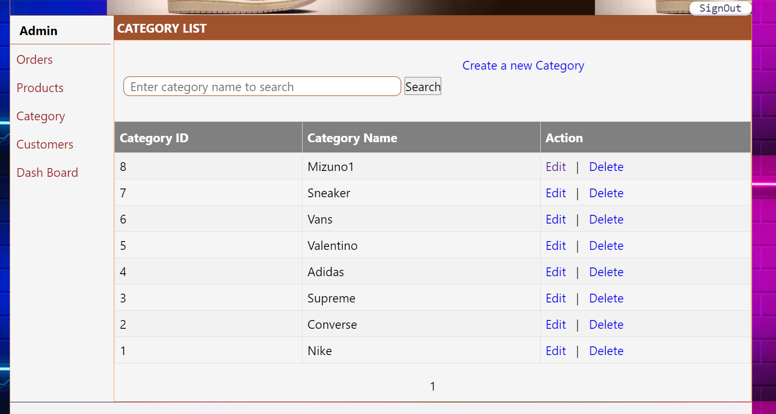

2.1.4 Luồng Admin quản lý Customers

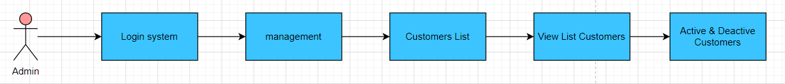

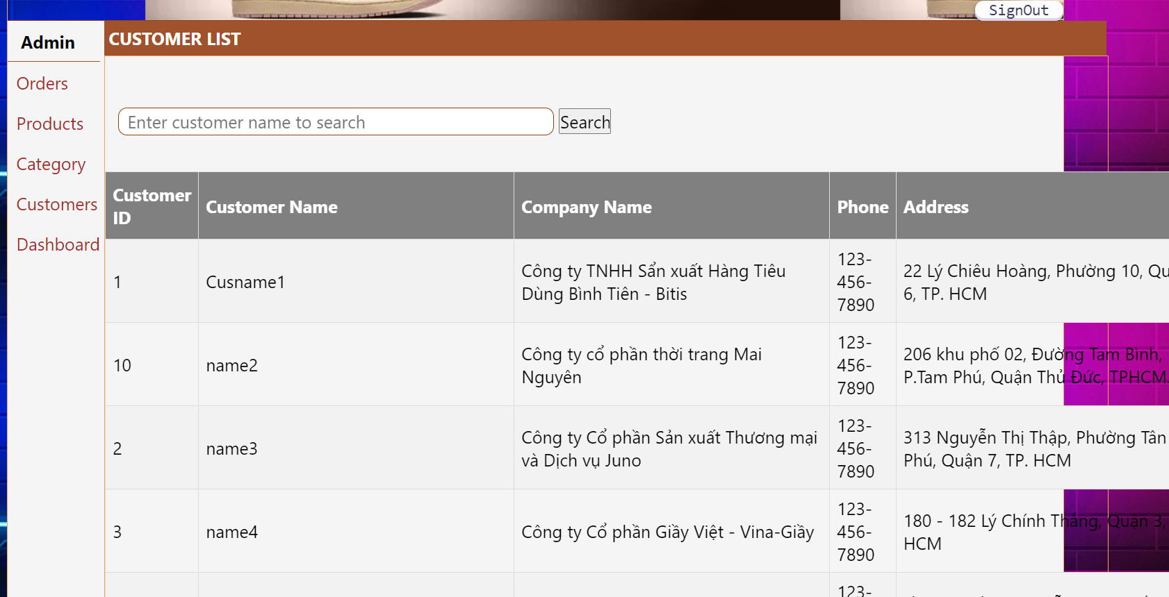

2.1.5 Luồng Admin quản lý DashBoard

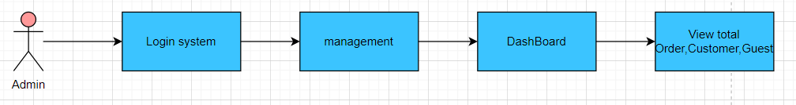

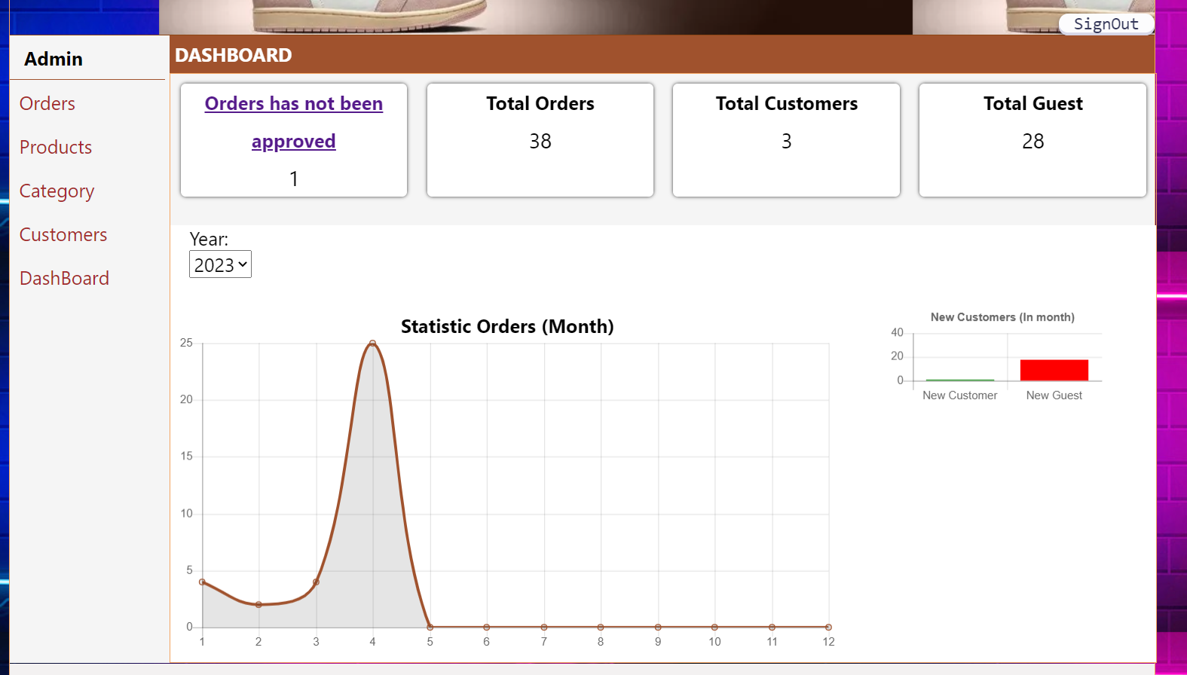

## 2.2. Guest

2.2.1 Luồng Guest xem trang chủ

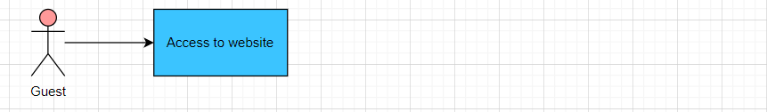

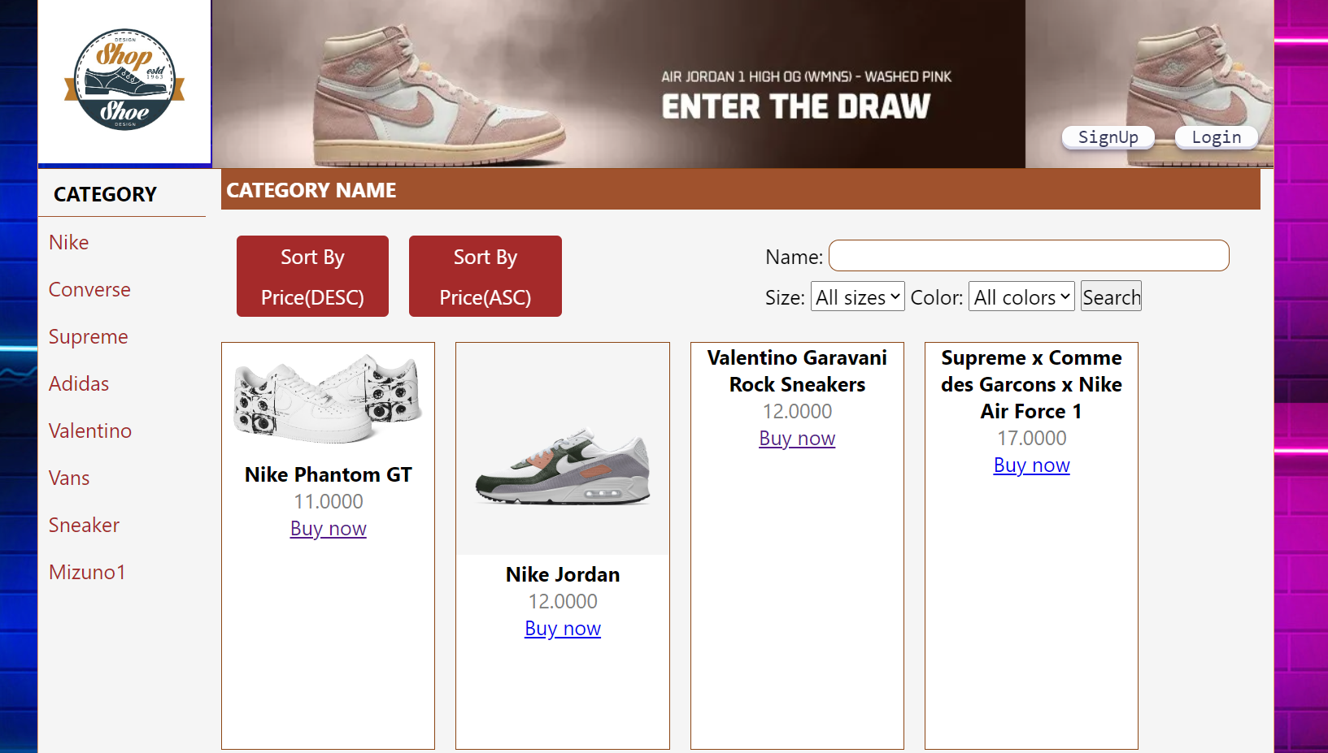

2.2.2 Luồng Guest mua hang

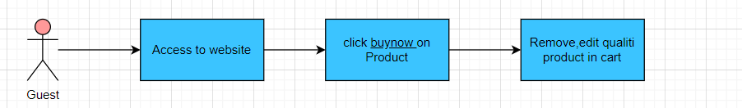

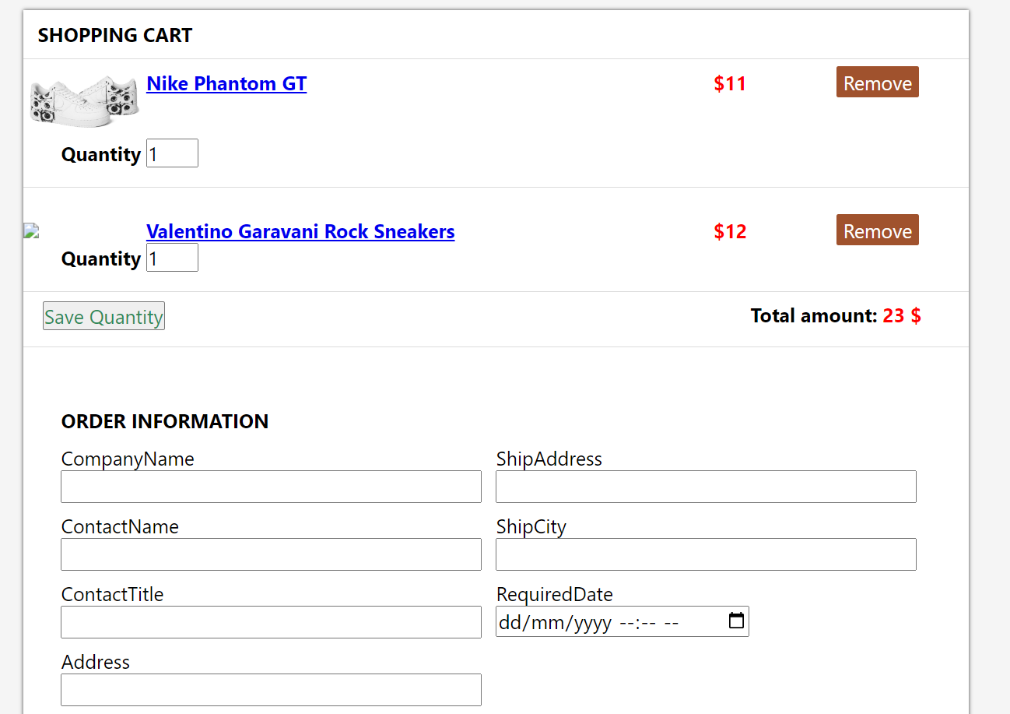

2.2.3 Luồng Guest đăng ký làm thành viên

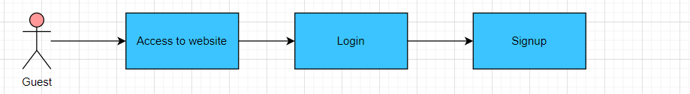

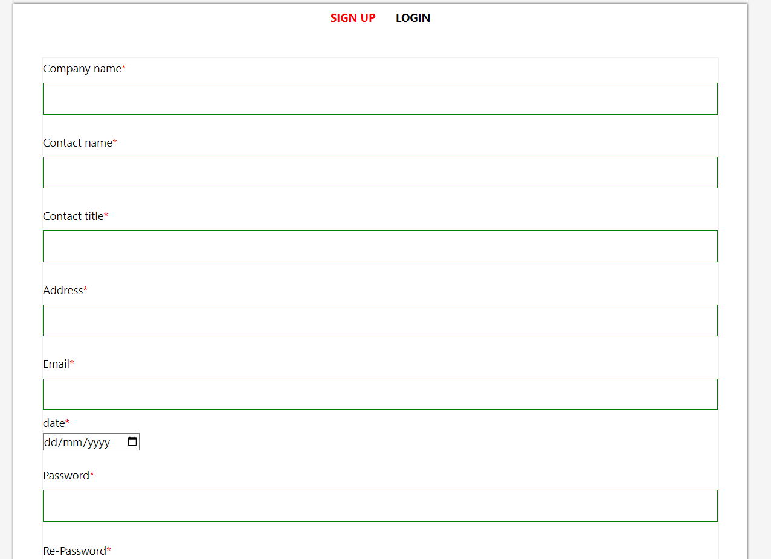

## 2.3. Customer

2.3.1 Luồng Customer xem thông tin của mình

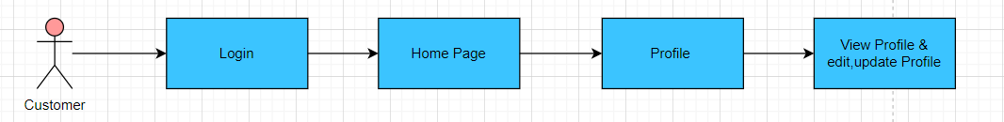

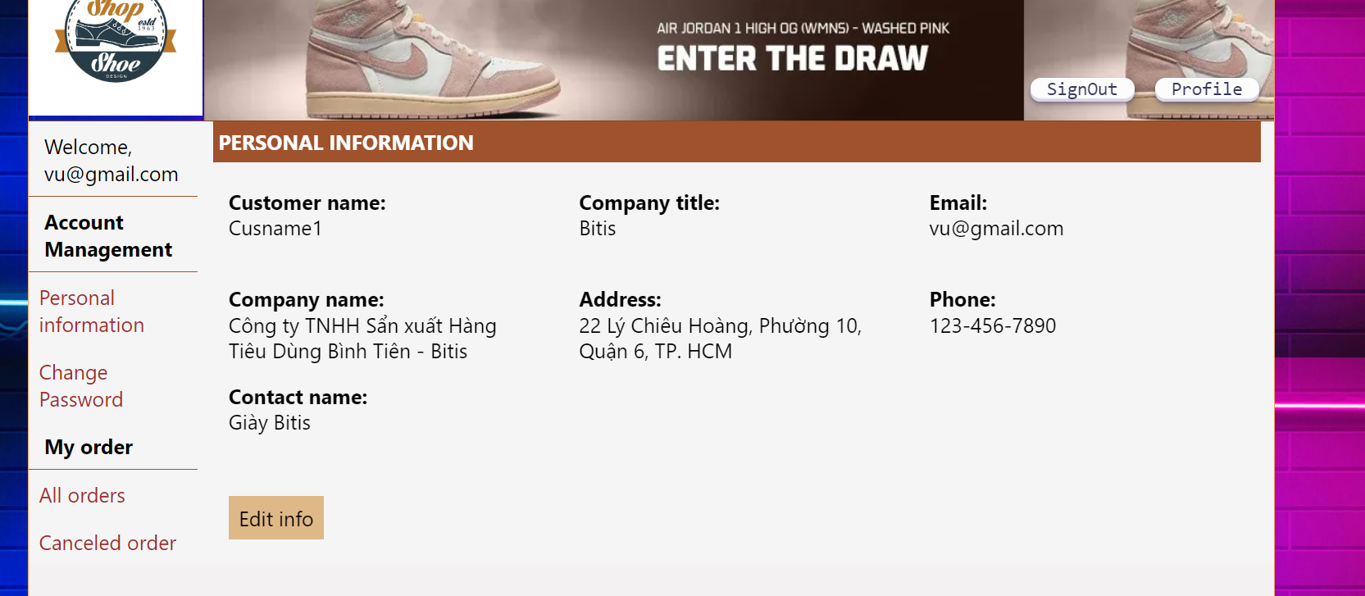

2.3.2 Luồng Customer đổi mật khẩu

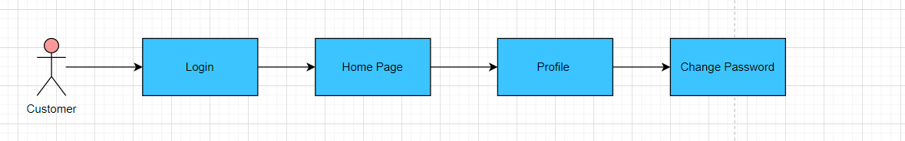

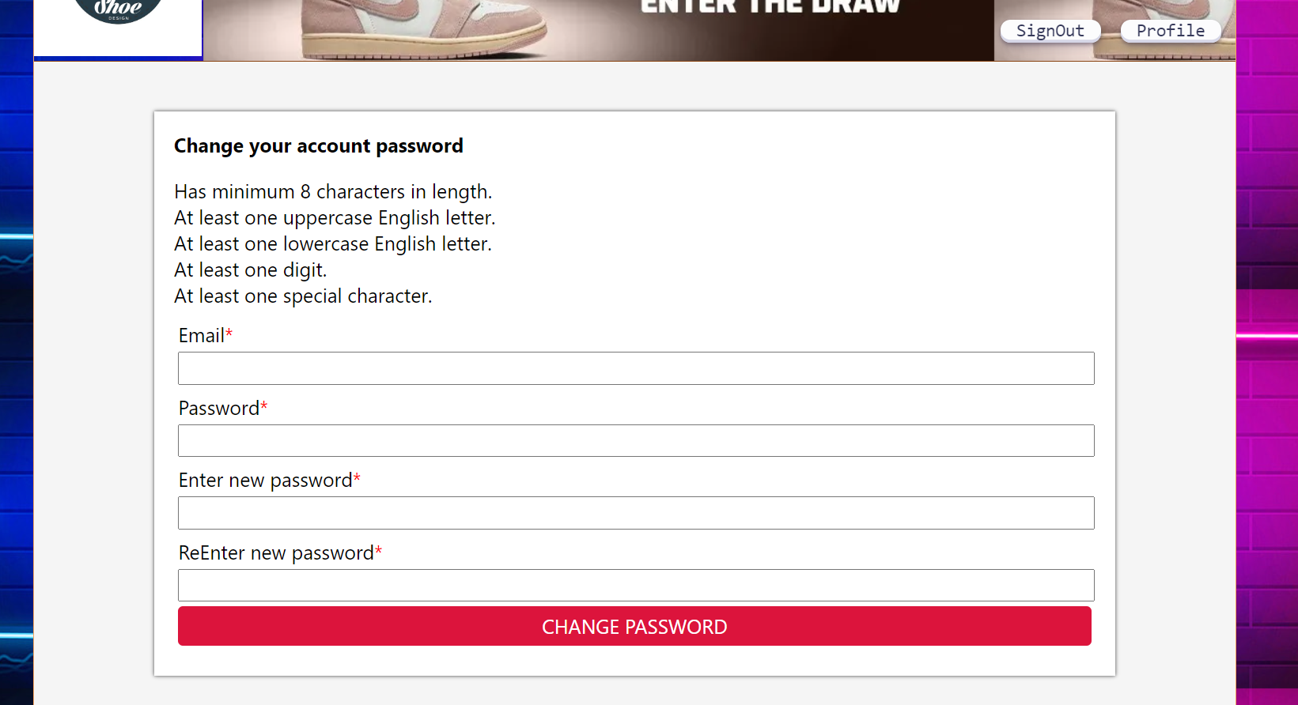

2.3.3 Luồng Customer mua hang

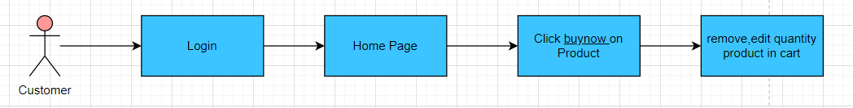

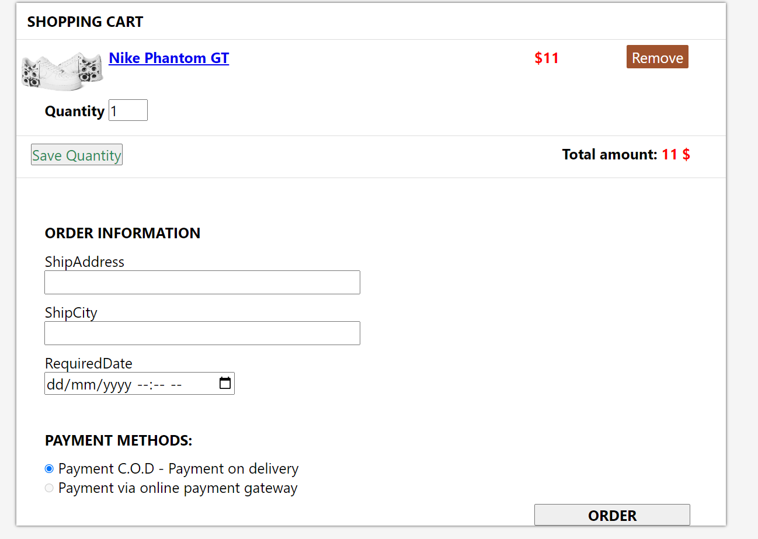

2.2.4 Luồng Customer xem lịch sử mua hàng

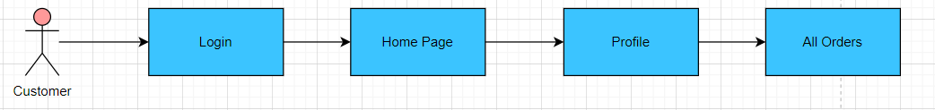

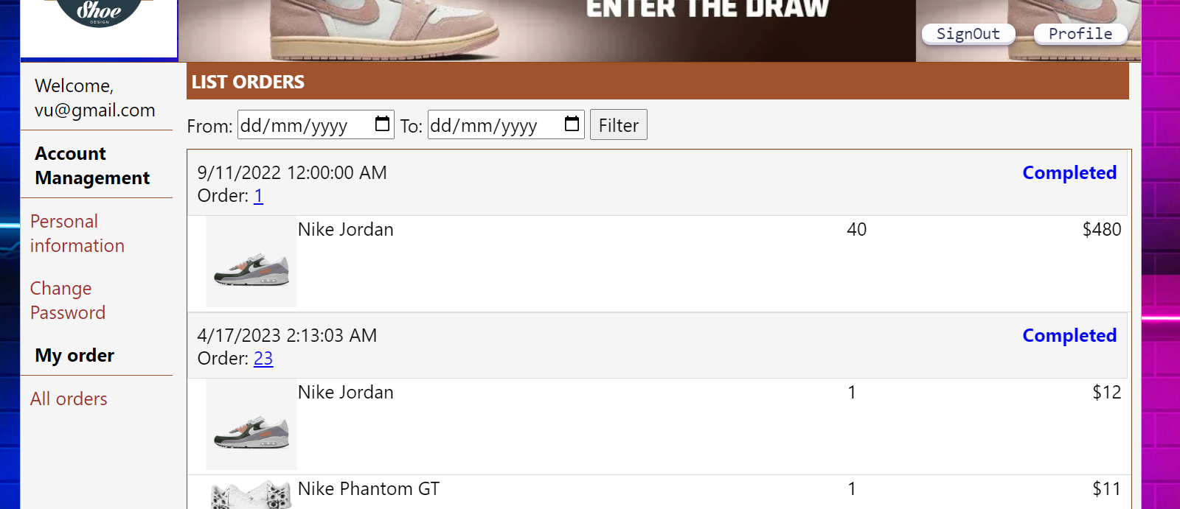

## 2.4. Employee

2.4.1 Luồng Employee quản lý số lượng sản phẩm

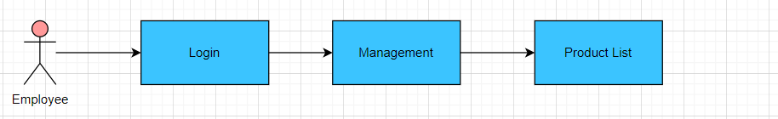

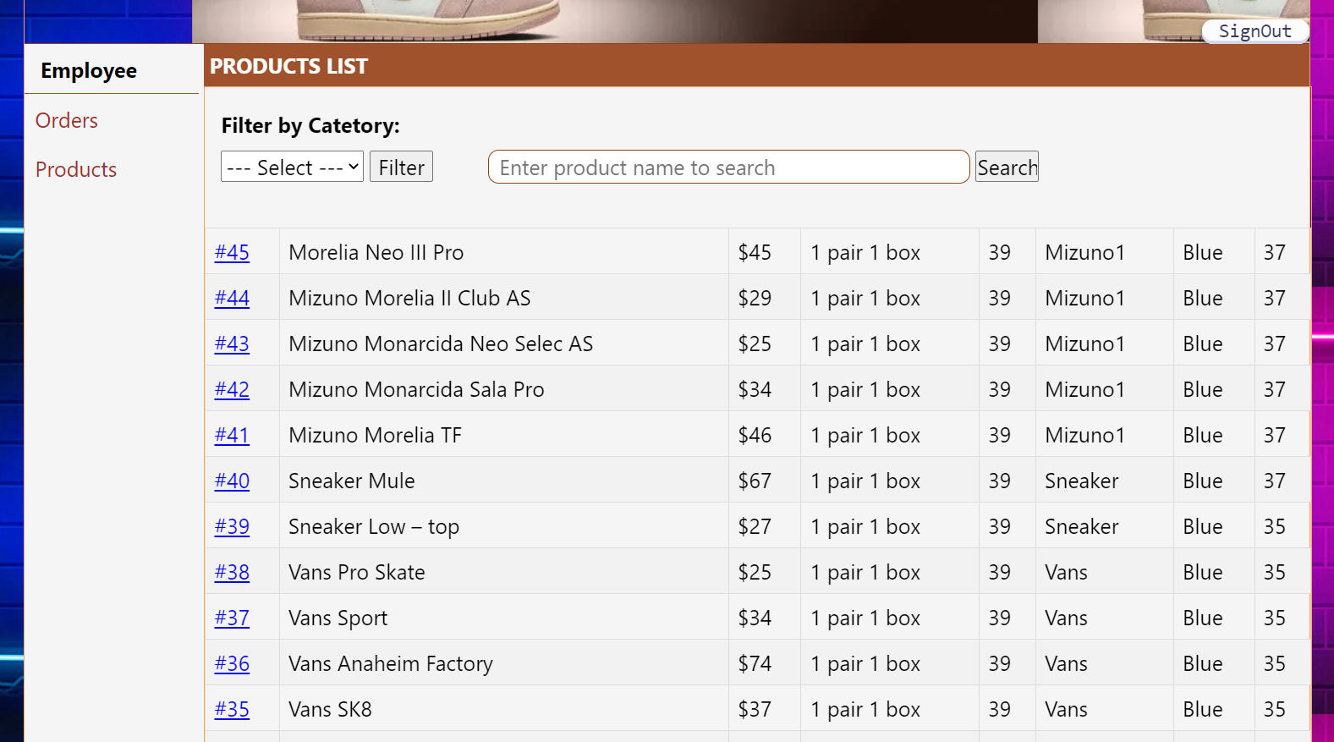

2.4.2 Luồng Employee xem trạng thái đơn hang của customer

